CA1601400 / CS4944 — Artificial Intelligence Lab
Lab 5: Adversarial Search — Minimax & Alpha-Beta Pruning
Student Name: | Rasikh Ali | Roll / Registration ID: | 42365
Week & Lectures: | Week 5 (L11–L12) | Mapped Outcome: | CLO2 (C3: Apply) | 3C: Competence

1. Inquiry & Trigger Questions (Section 3)
Q1: Why does MAX assume MIN will choose the worst outcome for MAX?
In a deterministic, two-player, zero-sum game, a gain for MAX is an equal loss for MIN. MAX therefore cannot rely on MIN making a poor move. A capable opponent will choose the response that gives MAX the lowest possible result. By planning for that response, MAX can choose a move with a guaranteed worst-case value.
Q2: What do alpha (α) and beta (β) represent?
Alpha (α) is the best value MAX can guarantee on the current search path. It starts at -∞. Beta (β) is the lowest value MIN can guarantee, or the upper limit MIN can hold MAX to on that path. It starts at +∞.
Q3: Does pruning change the optimal Minimax result?
No. Alpha-Beta pruning gives the same optimal result as a full Minimax search. A branch is skipped only when α ≥ β. At that point, one of the players already has an option that is at least as good, so the skipped branch cannot affect the final choice.
Q4: Why does move ordering affect pruning efficiency?
A cutoff occurs when α reaches or passes β. If the best moves for MAX and MIN are checked first, α can increase quickly and β can decrease quickly. This makes cutoffs more likely and can reduce the number of leaf evaluations from b^d toward b^(d/2). If weaker moves are checked first, the bounds improve more slowly and fewer branches may be pruned.

2. Lab Task 1: Manual Hand Trace of Supplied Game Trees
The lab manual provides two game trees for this task. Section 5.1 starts with 6 terminal scores, which are padded to 8 leaves. Section 5.2 provides a complete binary tree with 8 leaves. The calculations below evaluate both trees from the bottom level up using Minimax and Alpha-Beta pruning.

2.1 Trace A — Section 5.1 Tree: [3, 5, 2, 9, 0, 7] (Padded to [3, 5, 2, 9, 0, 7, 0, 0])
- Depth 3 (Terminal Leaves): Index 0..7 = [3, 5, 2, 9, 0, 7, 0, 0].
- Depth 2 (MAX Nodes): Node(2,0) = max(3, 5) = 5 | Node(2,1) = max(2, 9) = 9 | Node(2,2) = max(0, 7) = 7 | Node(2,3) = max(0, 0) = 0.
- Depth 1 (MIN Nodes): Node(1,0) = min(5, 9) = 5 | Node(1,1) = min(7, 0) = 0.
- Depth 0 (Root MAX Node): Node(0,0) = max(5, 0) = 5. Optimal Root Action: Left Branch (index 0).

2.2 Trace B — Section 5.2 Tree: [3, 5, 2, 9, 3, 5, 2, 9] with Alpha-Beta Bounds
Step | Active Node | Trace & Bound Update | Result / Cutoff Action
Step 1 | Depth 2, idx 0 (MAX) | Evaluates leaves L0=3 (α=3) and L1=5 (α=5). | Returns 5 to Left MIN node
Step 2 | Depth 1, idx 0 (MIN) | Updates β = min(+∞, 5) = 5. Calls right child (Depth 2, idx 1) with α=-∞, β=5. | Active window: [-∞, 5]
Step 3 | Depth 2, idx 1 (MAX) | Evaluates L2=2 (α=2 < β=5), then L3=9 (α=9 ≥ β=5). Loop ends. | Returns 9 to Left MIN node
Step 4 | Depth 1, idx 0 (MIN) | Computes min(5, 9) = 5 and returns 5 to Root MAX. | Root updates α = 5
Step 5 | Depth 2, idx 2 (MAX) | Called under Right MIN (α=5, β=+∞). Evaluates L4=3 (α=3), L5=5 (α=5). | Returns 5 to Right MIN node
Step 6 | Depth 1, idx 1 (MIN) | Updates β = min(+∞, 5) = 5. Now α=5 ≥ β=5 -> Cutoff triggered! | Prunes Depth 2, idx 3 [L6=2, L7=9]
Step 7 | Depth 0, idx 0 (MAX) | Compares Left=5 vs. Right≤5. Chooses Left Branch (index 0). | Optimal Value = 5 (6/8 leaves)

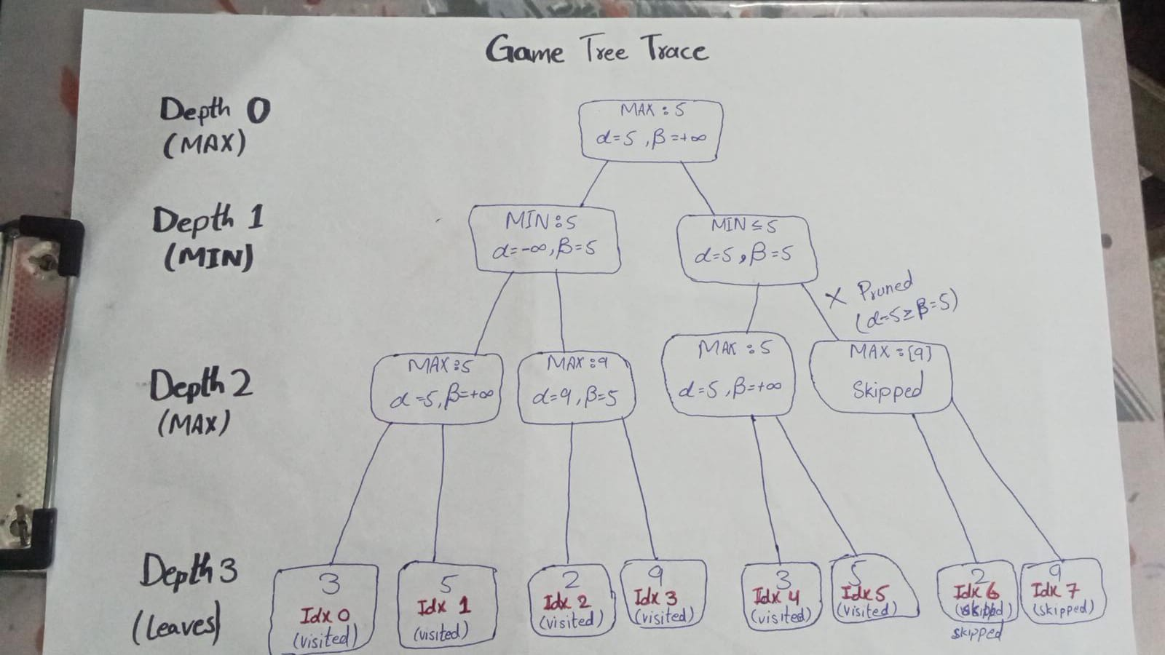
Figure 1: Visual game-tree trace on [3, 5, 2, 9, 3, 5, 2, 9] showing bottom-up utilities, α-β bounds, and the pruned right-most subtree.

3. Lab Tasks 2 & 3: Implementation, Code Reuse & Debugging
I reused and tested the reference implementations from Sections 5.1 and 5.2 of the lab manual. During testing, I found two issues in the Section 5.2 Alpha-Beta code and corrected them so that both algorithms return the same result:
- Child indexing fix: In Section 5.2, the call `alphabeta(depth+1, index*2+1, ...)` appeared inside `for i in range(2):`. Since `+1` was fixed, the loop visited the right child twice and skipped the left child. I changed the child index to `node_idx * 2 + offset`, so each iteration visits the correct child.
- Cutoff condition fix: The original Section 5.2 code used `if alpha > beta:`. This misses a valid cutoff when α == β, as in the right MIN node where α=5 and β=5. I changed the condition to `if alpha >= beta:` to include equality and allow the standard Alpha-Beta cutoff.
- Leaf evaluation counter: I added a `SearchTracker` class. It increases `leaf_count` whenever the search reaches a terminal node (`cur_depth == max_depth`) and records the indices of leaves that were evaluated, along with the pruning events.

4. Experimental Results: Branch Ordering & Edge Cases
For Task 3 and the case study checks, I ran seven scenarios. These included the original trees from Sections 5.1 and 5.2, versions with the left and right branches reordered, and two edge cases: one with equal terminal scores and one with all-negative utilities. The reordered trees represent the same game, but the order in which moves are checked is different.
Case | Scenario | Leaf Array | Root (Move) | MM Leaves | AB Leaves | Saved
Case 1 | 5.1 Original Padded | [3, 5, 2, 9, 0, 7, 0, 0] | 5 (Left) | 8 | 8 | 0.0%
Case 2 | 5.1 Reordered Best-First | [5, 3, 9, 2, 0, 0, 7, 0] | 5 (Left) | 8 | 5 | 37.5%
Case 3 | 5.2 Standard Order | [3, 5, 2, 9, 3, 5, 2, 9] | 5 (Left) | 8 | 6 | 25.0%
Case 4 | 5.2 Best-First Ordering | [5, 3, 9, 2, 5, 3, 9, 2] | 5 (Left) | 8 | 5 | 37.5%
Case 5 | 5.2 Worst-First Ordering | [2, 9, 3, 5, 2, 9, 3, 5] | 5 (Left) | 8 | 8 | 0.0%
Case 6 | Edge: Tied Utilities | [4, 4, 4, 4, 4, 4, 4, 4] | 4 (Left) | 8 | 5 | 37.5%
Case 7 | Edge: All Negative | [-8, -3, -12, -1, -6, -9, -4, -2] | -3 (Left) | 8 | 6 | 25.0%

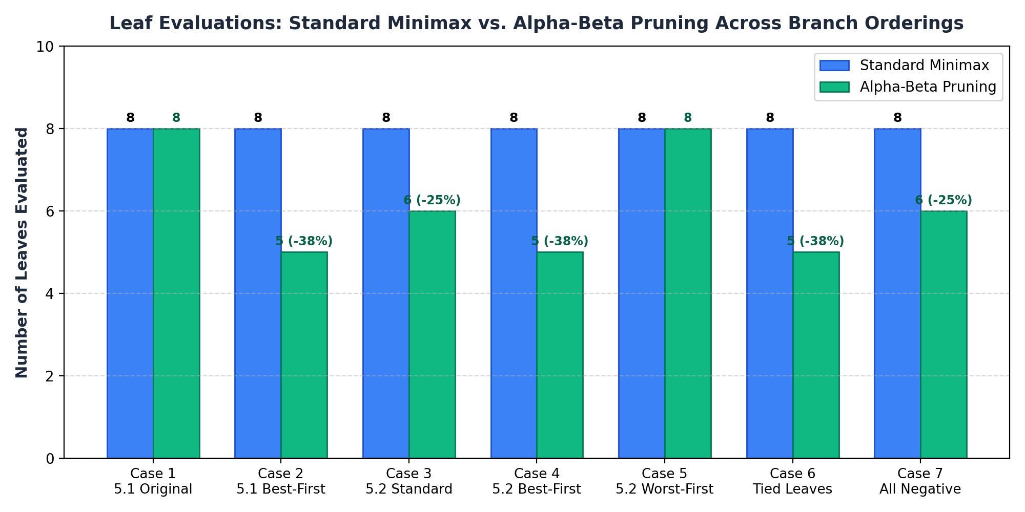
Figure 2: Comparison of evaluated leaf counts between plain Minimax and Alpha-Beta Pruning across all 7 test configurations.

5. Analysis, Edge Cases & Viva-Ready Design Choices
Why 5 Leaves Is the Theoretical Minimum for Depth 3: For a binary tree with depth d = 3 and 8 leaves, the minimum number of leaves Alpha-Beta must evaluate is b^ceil(d/2) + b^floor(d/2) - 1 = 2^2 + 2^1 - 1 = 5. Cases 2, 4, and 6 reach this minimum. They evaluate 5 leaves, saving 37.5%, while keeping the same Minimax root value.
Isomorphic Branch Reordering (Cases 3, 4, and 5): These three cases use the same game tree, with sibling branches swapped. Each produces a root value of 5. However, Alpha-Beta evaluates 6 leaves in Standard order, 5 in Best-First order, and all 8 in Worst-First order. The results show that move order affects how much pruning takes place, while the best decision stays the same.
Edge Case Verification (Ties and Negative Utilities): Case 6, with all terminal scores equal to 4, shows why the cutoff condition must be α ≥ β rather than α > β. Equality allows redundant branches to be pruned. Case 7 uses only negative payoffs and confirms that α = -∞ and β = +∞ are the correct starting values. Starting at 0 could cause incorrect cutoffs when every outcome is negative.
Limitations and Failure Modes in Real Games: 1) In deep games such as Chess or Go, the number of possible states grows exponentially. Searching all the way to terminal states is often impractical, so the algorithm needs a depth limit and a heuristic evaluation function. 2) Minimax assumes an opponent who always chooses the best response in a zero-sum game. If the opponent behaves unpredictably or makes irrational choices, Expectimax may be a more suitable approach.

6. Student Reflection & Responsible AI Practice (Section 8)
• What did you learn today? I learned how adversarial games use alternating MAX and MIN levels. Minimax works upward from the terminal scores to find the guaranteed value, while Alpha-Beta pruning skips branches that cannot change the final decision.
• How will you apply this in a real AI system? For a game-playing agent or a system used for negotiation or security planning, I would combine Alpha-Beta pruning with useful move-ordering rules. For example, checking captures or high-priority responses first can help the system search further within a limited amount of time.
• What failed or surprised you? When I first ran the original Section 5.2 code, it returned 9 instead of 5. I checked the visited leaf indices and found that `index*2+1` made the loop visit only right-hand children. After correcting the child index and changing `alpha > beta` to `alpha >= beta`, the results matched and the expected cutoff occurred.
• What would you do differently next time? I would extend the array-based tree into a general node/state structure. This could support different numbers of children, depth-limited searches with heuristic evaluations, and iterative deepening with a transposition table.
• Character Integration (Transparency and Reproducibility): I recorded the visited leaf indices, root subtree scores, and each `[alpha >= beta]` cutoff in the console output and diagrams. These details let another student or the instructor follow the search and check how each decision was made.

